**TASK 1**

**Project Title: OLAP Operations**

**Project Description:**

Develop the queries to retrieve information from the OLAP operations performed and to gain a

deeper understanding of the sales data through different dimensions, aggregations, and filters.

**Github Link -** <https://github.com/Dishikamehndiratta/OLAP-Operations>

**1. Database Creation**

**Code-** CREATE DATABASE SalesDatabase;

USE SalesDatabase;

**2. Creation of Table**

**Code-** CREATE TABLE sales_sample (

Product_Id INT NOT NULL,

Region VARCHAR(50) NOT NULL,

Date DATE,

Sales_Amount NUMERIC NOT NULL);

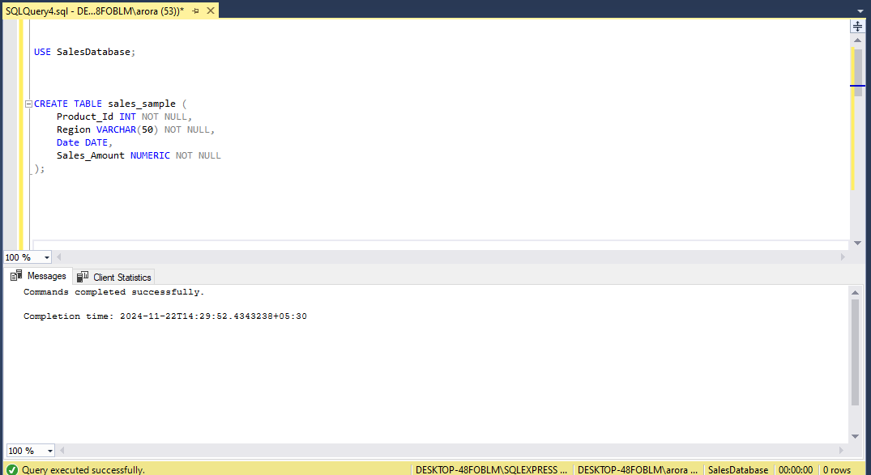

**3.Insertion of Values**

**Code-** INSERT INTO sales_sample (Product_Id, Region, Date, Sales_Amount)

VALUES

(101, 'North', '2023-01-01', 5000),

(102, 'South', '2023-01-02', 6000),

(103, 'East', '2023-01-03', 7000),

(104, 'West', '2023-01-04', 8000),

(105, 'North', '2023-01-05', 5500),

(106, 'South', '2023-01-06', 6500),

(107, 'East', '2023-01-07', 7500),

(108, 'West', '2023-01-08', 8500),

(109, 'North', '2023-02-01', 5600),

(110, 'South', '2023-02-02', 6700);

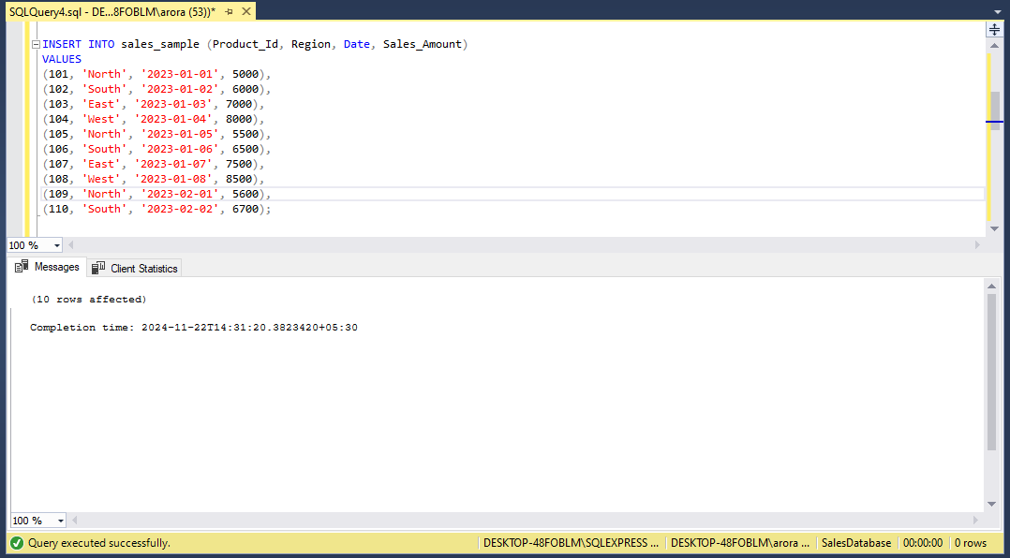

**4. a) Drill Down-Analyze sales data at a more detailed level.Write a query to perform drill down from region to product level to understand sales performance.**

**Code-** SELECT Region, Product_Id, SUM(Sales_Amount) AS Total_Sales

FROM sales_sample

GROUP BY Region, Product_Id

ORDER BY Region, Product_Id;

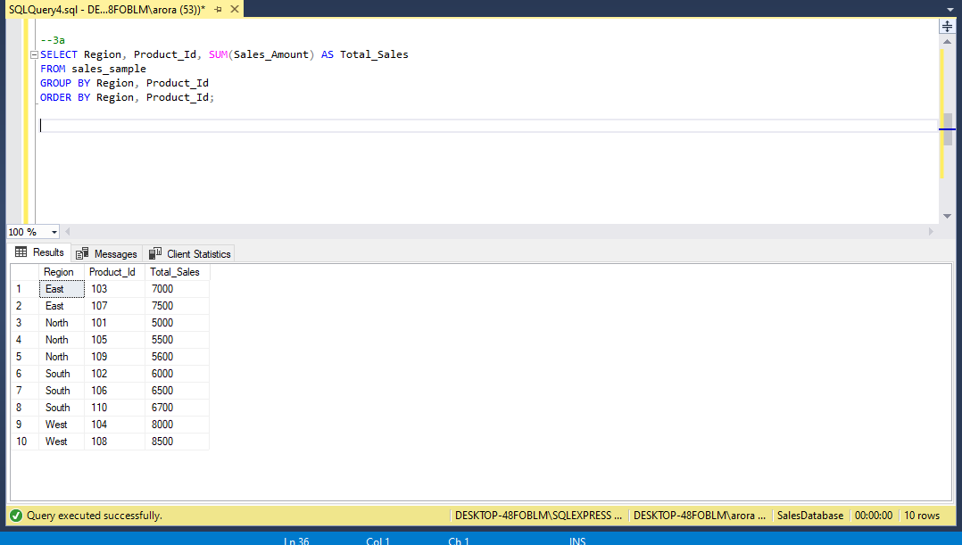

**b) Rollup- To summarize sales data at different levels of granularity.Write a query to perform roll up from product to region level to view total sales by region.**

**Code-** SELECT Region, Product_Id, SUM(Sales_Amount) AS Total_Sales

FROM sales_sample

GROUP BY ROLLUP(Region, Product_Id)

ORDER BY Region, Product_Id;

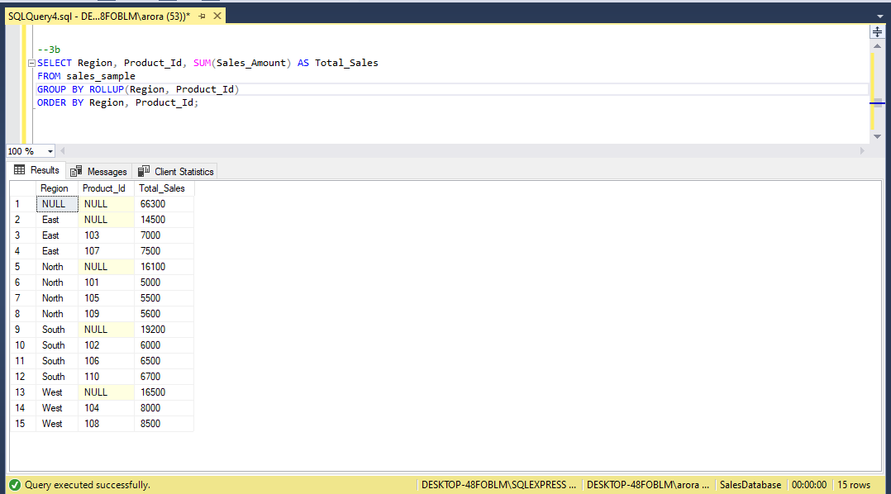

**c) Cube - To analyze sales data from multiple dimensions simultaneously.Write a query to explore sales data from different perspectives, such as product, region, and date.**

**Code-** SELECT Product_Id, Region, Date, SUM(Sales_Amount) AS Total_Sales

FROM sales_sample

GROUP BY CUBE(Product_Id, Region, Date)

ORDER BY Product_Id, Region, Date;

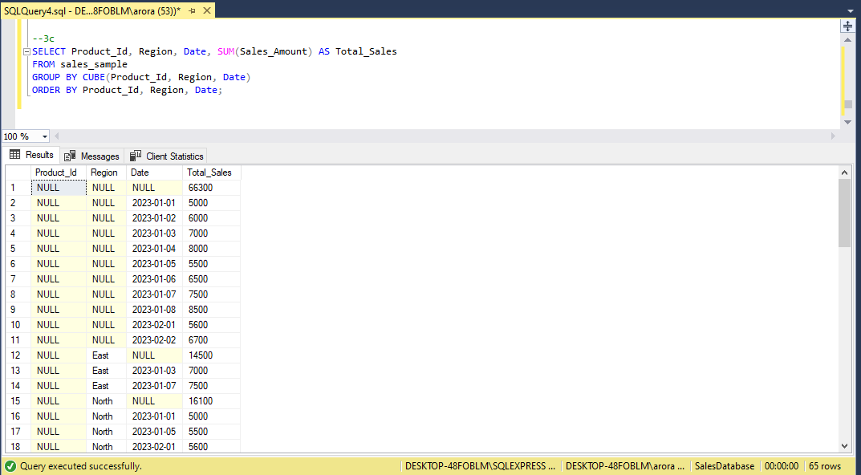

**d) Slice- To extract a subset of data based on specific criteria.Write a query to slice the data to view sales for a particular region or date range.**

**Example 1: Slice by Region**

**Code-** SELECT Product_Id, Region, Date, SUM(Sales_Amount) AS Total_Sales

FROM sales_sample

WHERE Region = 'East'

GROUP BY Product_Id, Region, Date

ORDER BY Date;

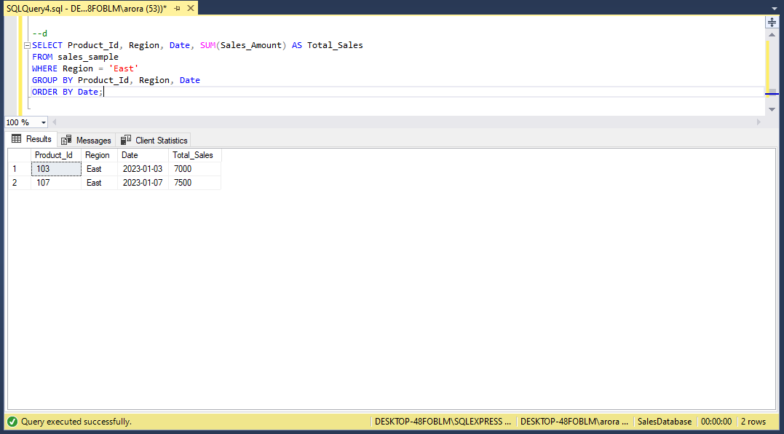

**Example 2: Slice by Date Range**

**Code-** SELECT Product_Id, Region, Date, SUM(Sales_Amount) AS Total_Sales

FROM sales_sample

WHERE Date BETWEEN '2023-01-01' AND '2023-02-01'

GROUP BY Product_Id, Region, Date

ORDER BY Date;

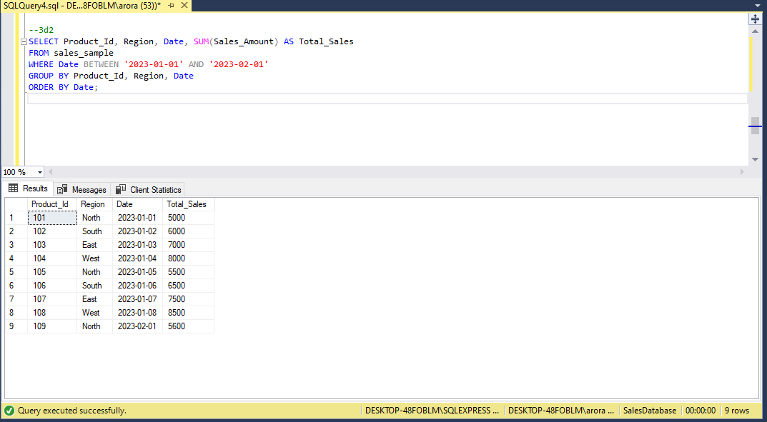

**e) Dice - To extract data based on multiple criteria. Write a query to view sales for specific combinations of product, region, and date.**

**Suppose you want to view sales data for the following combinations:**

* **Product_Id = 101** and **Region = 'East'**
* **Product_Id = 102** and **Region = 'South'**
* **Date = '2023-01-02'**

**Code-** SELECT Product_Id, Region, Date, SUM(Sales_Amount) AS Total_Sales

FROM sales_sample

WHERE (Product_Id = 101 AND Region = 'East')

OR (Product_Id = 102 AND Region = 'South')

OR (Date = '2023-01-02')

GROUP BY Product_Id, Region, Date

ORDER BY Date, Product_Id, Region;

